**Chapter 1:**

* Effective communicators understand the needs of the context in which they are speaking and writing, what Lloyd Bitzer has labeled the **“rhetorical situation.”**

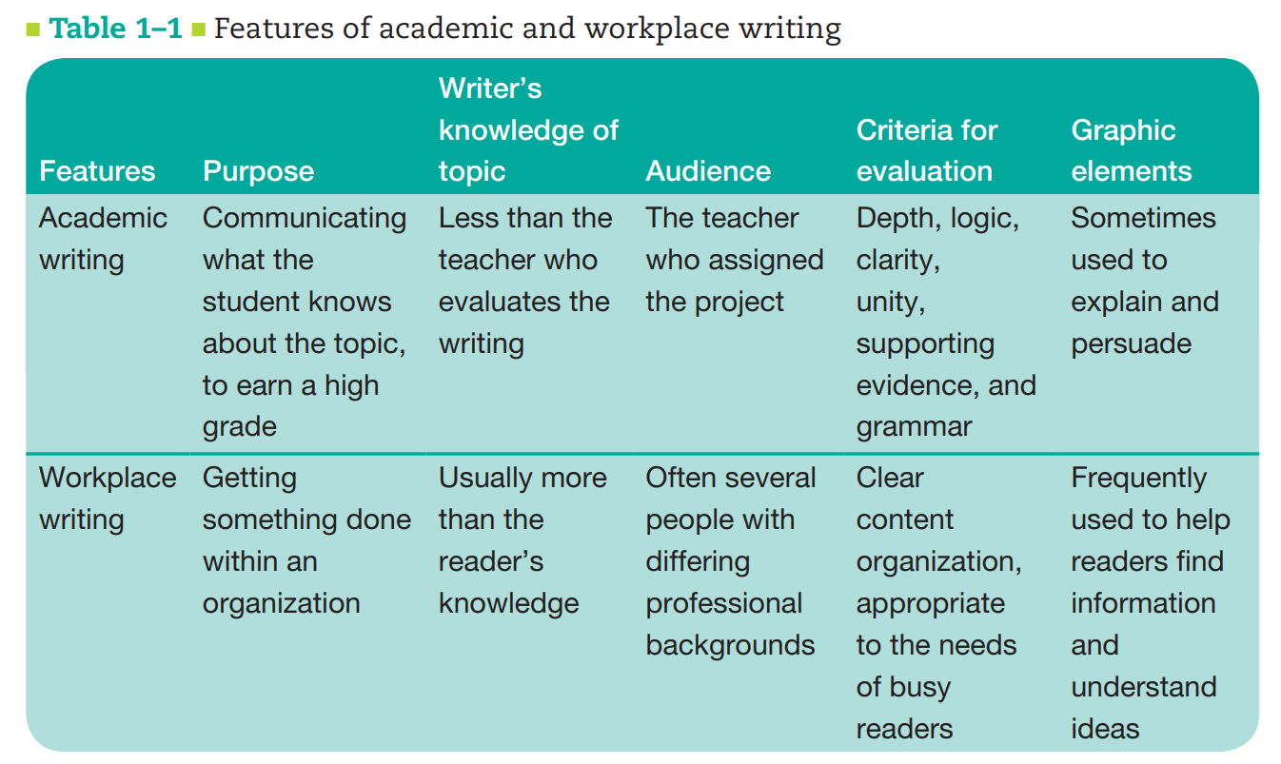

* The terms professional writing, business writing, and occupational writing also refer to writing done in your career
* Organizations depend on writing for clear communication, effective action, and necessary record keeping.
* You may be writing to readers in the following groups:

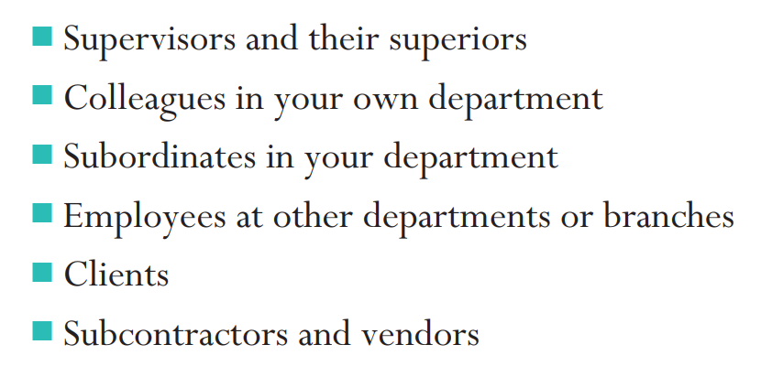

* **Examples of technical communication:**

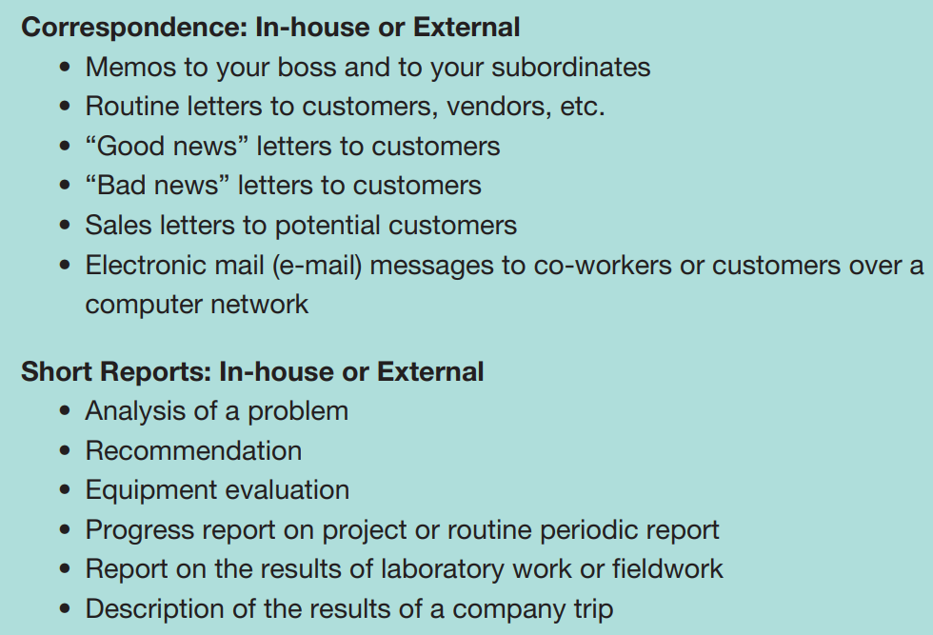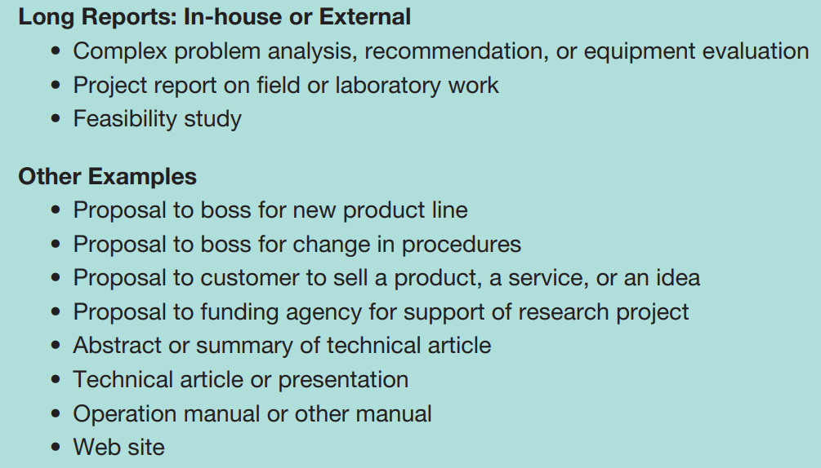

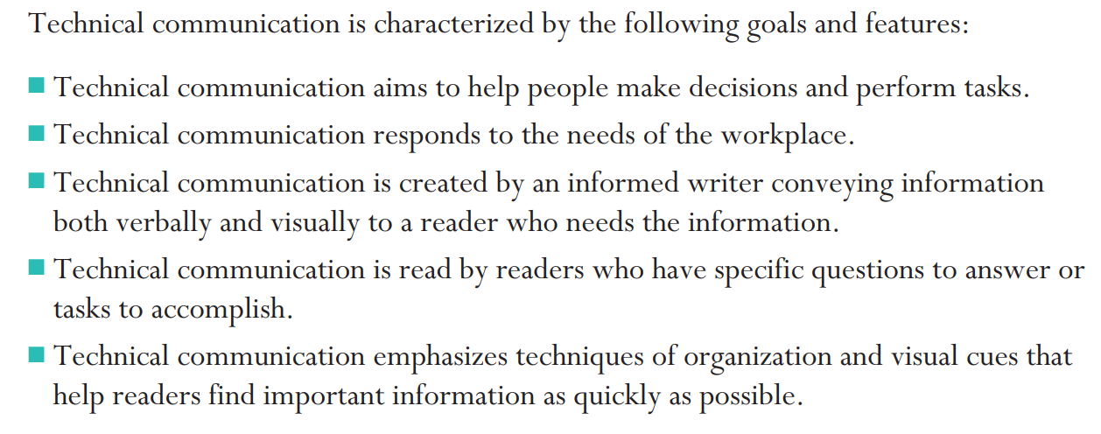

**Elements of an Organization’s Culture:**

Organizational culture: The main features of life at a particular organization. An organization’s culture is influenced by the firm’s history, type of business, management style, values, attitude toward customers, and attitude toward its own employees.

Any organization you join has its own personality: a firm’s history, its type of business, and its management style.

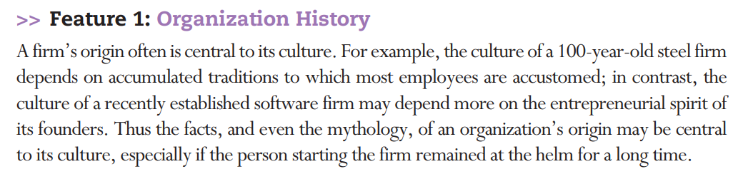

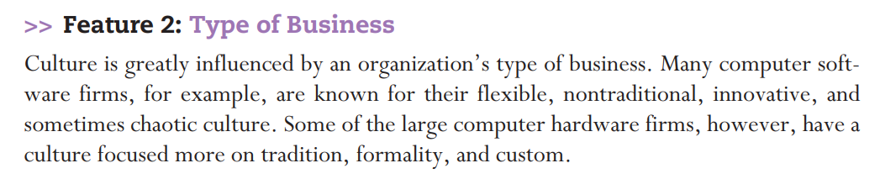

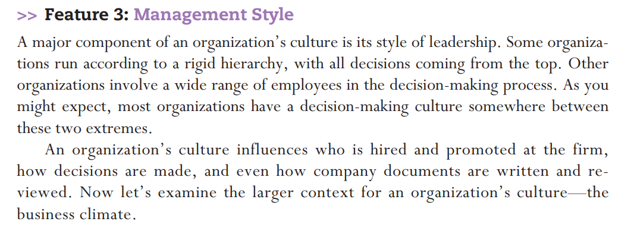

**Business Climate:**

* Business climate: The economic and political factors that influence an organization’s priorities, plans, and activities. These factors include competition, investor interests, regulations, and the overall health of the economy.
* To improve quality, companies seek to respond quickly to customer needs and to encourage employee interest in the success of the organization through an emphasis on team building and employee input.
* To improve efficiency, companies work to improve productivity while reducing costs.
* Two practices that are being used more often in the global business climate are **outsourcing and offshoring.**
* **Outsourcing** is the practice of purchasing goods or subcontracting services from an outside company. Both the client company and the company that is providing the goods or services may be in the same country, or they may be in different countries.
* **Offshoring** happens when a company moves some of its operations to another country. This practice is often done to reduce labor costs, but it may also help a company work more efficiently by creating offices closer to suppliers or clients.

**Understanding Culture:**

* Emphasizing differences can lead to inaccurate stereotypes; large generalizations about people can be misinformed and thus can impede, rather than help, communication.
* Emphasizing similarities can tend to mask important differences by assuming we are all alike—one big global family.
* The truth is somewhere in between.
* People in different cultures have different ways of thinking, different ways of acting, and different expectations in communication. It requires that we understand not only what people do, but also why they do it.
* **High-context cultures** are fairly homogeneous, with the culture providing a high degree of context for communication. Thus, communications may be less explicit because members of the culture share characteristics such as religion, ethnic background, and education.
* Important characteristics of high-context cultures include

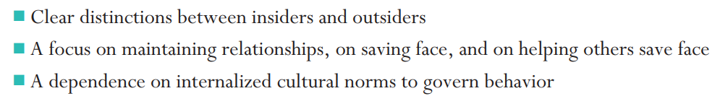

* **Low-context cultures** consist of diverse religions, ethnic backgrounds, and educational levels; as a result, communication must be explicit, because members of a group cannot assume that they share knowledge or attitudes. The culture provides a low degree of context for communication

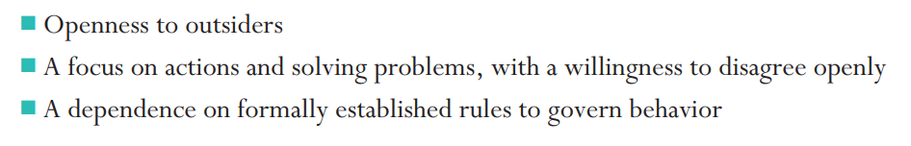

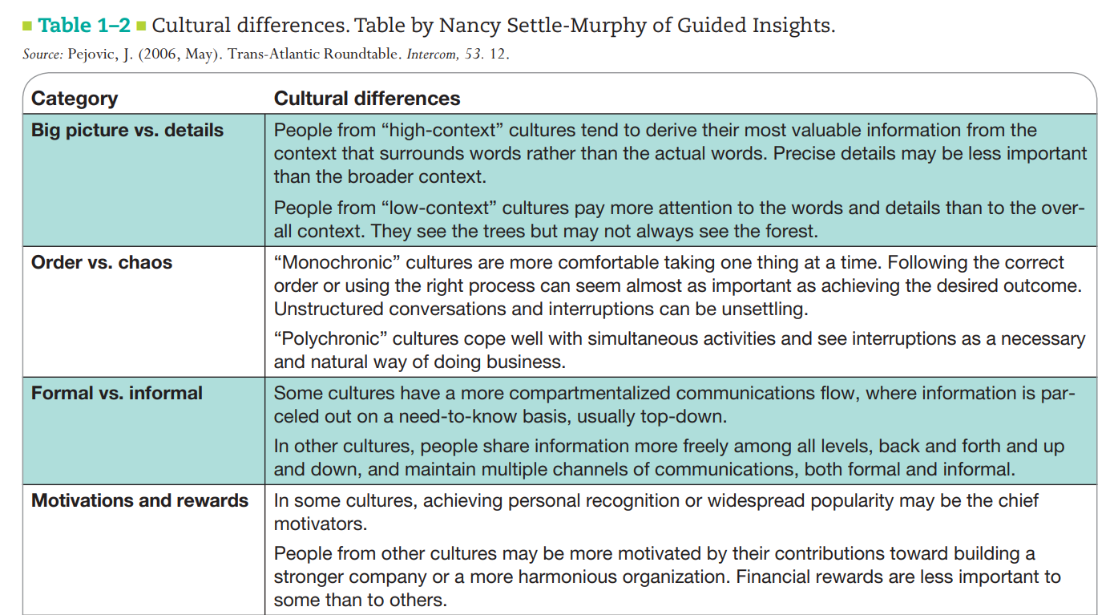

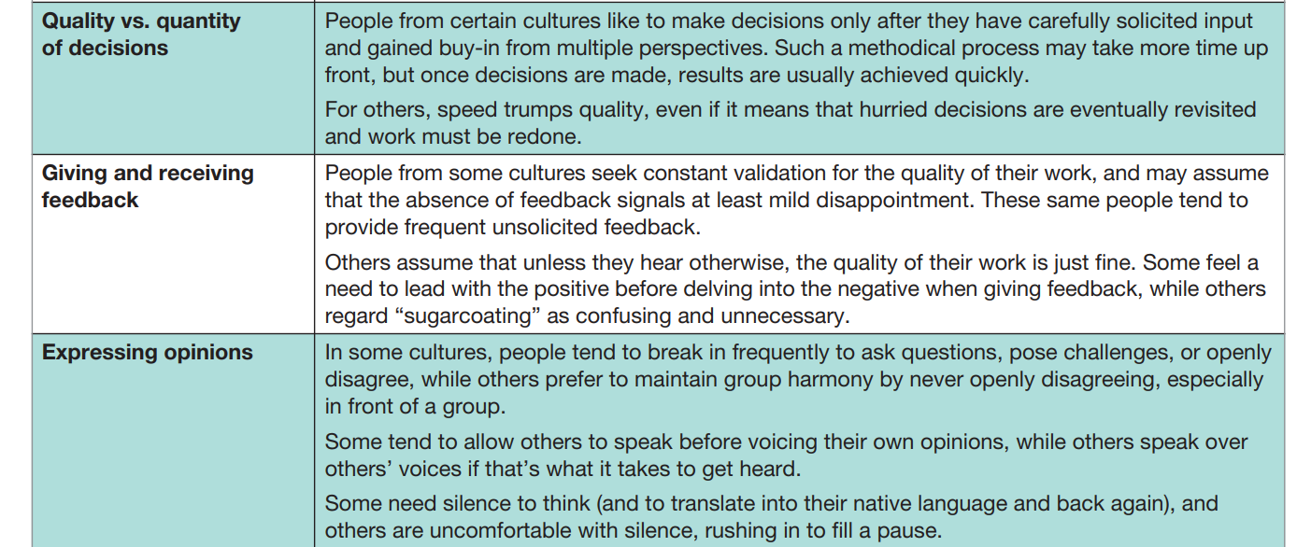

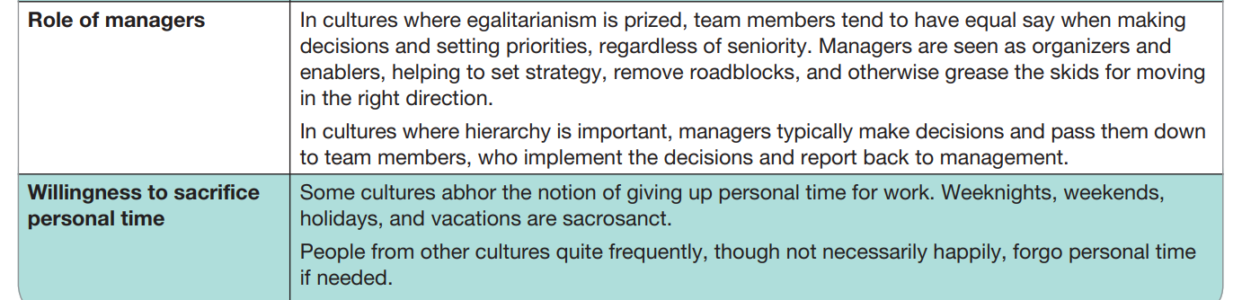

* Intercultural knowledge translates into power in the international workplace. If we are aware of diversity, then we are best prepared to act
* When writing documents for other cultures, remember that your work will not be read in the cultural context in which it was written. For that matter, you may lose control of the document altogether if it is translated into a language that you do not know. In order to help solve this problem, use **Simplified English**, also known as **Controlled English**

Following are some basic guidelines to reduce the risk of misunderstanding:

* Simplify grammar and style rules.
* Use simple verb tenses and verb constructions
* Limit vocabulary to words with clear meanings
* Use language and terminology consistently.
* Define technical terms
* Avoid slang terms and idioms.
* Include visuals.

**Ethical Guidelines for Work:**

* Be Honest
* Be Fair
* Be Professional
* Honor Intellectual Property Rights
* Respect Confidentiality
* Do No Harm

**Legal issues in writing:**

* Acknowledge Sources for Information Other Than Common Knowledge
* Acknowledge Sources for Information Other Than Common Knowledge
* Seek Written Permission Before Borrowing Graphics
* Seek Legal Advice When You Cannot Resolve Complex Questions